**Institute of Technology Tralee**

**Ord/Hons BSc. in Computing with Specialism (Sample 1) - Year 1**

**Continuous Assessment #1**

**Date:**

**Time:**

**Object Oriented Programming 1**

**Instructions:** Attempt the following question. You should use the JCreator IDE. When you are finished coding, print out your code in **landscape** format.

**________________________________________________________**

**Q1.**

According to the 2014 budget, the Irish government collects pay-related social insurance (PRSI) from its citizens based on their gross income and the “class” of the citizen’s employment, which varies according to whether the citizen is an employee, is self-employed etc. Some of the rates at which PRSI must be paid is based on the following table:

|  |  |
| --- | --- |
| **Rate** | **Class** |
| 4% on all gross income, if income exceeds €18304, 0% otherwise | A |
| 0.9% on gross income up to €75036 and 4% on everything else | B, C, D |
| 4% on all gross income or €500, whichever is greater | S |
| No PRSI to be paid | All other classes |

Your program should read in the gross income and the class of the citizen in the main(), and then call a user-defined method **PRSICalculator**() which takes as arguments the gross income and class data and uses the table of values above to return the PRSI that the citizen must pay. Once this value is returned to main(), the PRSI due should be displayed to **2 decimal places**. Note that you do not need to validate the gross income or PRSI class values in any way.

For full marks your program should, along with a logically correct solution for the problem above, include **comments** and **meaningful variable names**.

Your program should run exactly as indicated in the following sample screenshots. Also, you should use the test values indicated when testing your own program. Note that the screenshots below only test a few of the many possibilities so make sure you **test your program fully**.

**Sample Screenshots**

**Run 1 – an income of €20000.56 and a PRSI class of A**

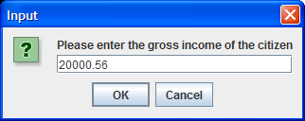 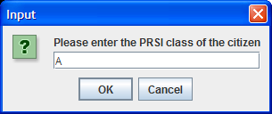

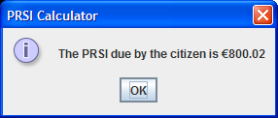

**Run 2 – an income of €50505.55 and a PRSI class of S**

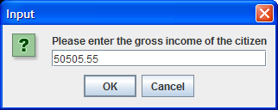 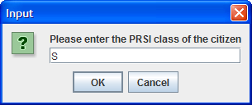

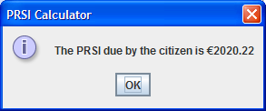

**Run 3 – an income of €65023.45 and a PRSI class of C**

